PSD

Student name

Department of Electronic and Communications Engineering,
Faculty of Engineering, University of Kufa, Iraq.

Abstract
This template represents the basic guidelines and desired layout of your final manuscript of the Magazine of Student Research (MOSR). It is compulsory that you use this template for the preparation of your paper. The formatting is rather straightforward as you just need to copy and paste your text over this one making sure to retain this sample font type, size, etc. This article plays the role of a template as well as the guidelines for prospective authors who will have to prepare the final manuscript accepted for publication by MOSR.

Keywords: Keyword-1; Keyword-2; Keyword-3; Keyword-4; Keyword-5.

1. Introduction
These instructions give you the guidelines for preparing papers for MOSR. Use this document as a template. To ensure publication quality and uniformity, the following requirements have been prepared to assist authors in preparing papers for the Magazine of Student Research. If these requirements are not followed, papers will be returned for revision and re-submittal.

2. Format of manuscript
The paper should be written in A4 (210 mm by 297 mm) size. Your manuscript should be on one side of a sheet, with margins of 2.3 cm on all sides. Distance from edge must be 1.27 cm from header and footer. The subsequent headings are called subsection. All fonts are Times New Roman, single spaced.

2.1 Main title and author affiliation
The title of the paper must be centered at the top of the page; it has to be Times New Roman bold 20 pts not typed in capital letter. Leave two line spaces of 11 pts and give the name(s) of the supervisor(s), also leave one line of 11 pts and give the names of the students. The font size of the supervisor(s) is bold 14 pts and the font size of the students is bold 12 pts. Leave one line spaces of 11 pts and give the authors’ affiliation. The font size of the authors’ affiliation is 11 pts.

2.2 Abstract and keywords
Leave two lines space of 11 pts and then write the abstract. Before the body of the abstract and the keywords, the terms "Abstract" and "Keywords:" should come in bold 11 pts, respectively. Skip a line space of 11 pts between the end of the abstract and the keywords. Keywords are usually composed of about five terms or phrases in alphabetical order, separated by commas. Leave three lines space of 11 pts after keywords. Refers to the example for the dimension and the position.
2.3 Body
The font sizes of the section headings are bold 11 pts and those of the subsection headings italic 11 pts, respectively. The text body has to be Times New Roman 11 pts and fully justified. Please do not place any additional blank lines between paragraphs. As for the fonts and the sizes of the headings, this manuscript in itself constitutes a good example.

3. Figures
Figures and their captions must be centered. Number figures consecutively in the order of appearance and refer to them as Figure 1. Place figure captions below the figures. If your figure has two parts, include the labels “(a)” and “(b)”. Letters in the figure should be large enough to be readily legible when the drawing is reduced. Do not forget to include the label, unit for each axis and the legend when they are required. Please do not include captions as part of the figures. Do not put captions in “text boxes” linked to the figures. Do not put borders around the outside of your figures. Leave one line space of 11 pt before and after the figure.

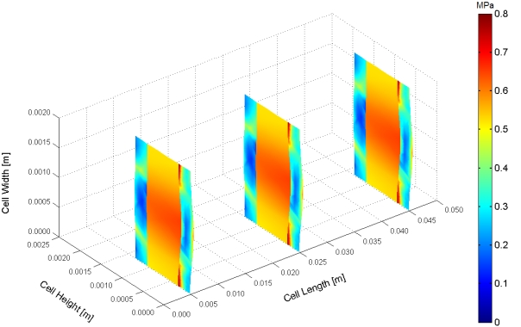

Figure 1. Sample of figure for the magazine of student research.

4. Tables
Tables and its titles must be centered. Number tables consecutively in order of appearance and place them as close as possible to where they are first referenced in the text. Place table titles above the tables. Refer to tables as Table 1 or Tables 1 and 2, in the body of text. Leave one line space of 11 pt before and after the table.

Table 1. Sample of table for the magazine of student research.

A | B | C [mm] | D [MPa] | E [ppm]
1e-5 | 1.234 | 1 | 1 | 1
2e6 | 20.123 | 2 | 2 | 2
3.312e-5 | 300.123 | 3 | 3 | 3
6e-4 | 600.001 | 4 | 4 | 4
7e-5 | 7.123 | 5 | 5 | 5

5. Units
It is strongly encouraged that the authors use SI (International System of Units) units only.

6. Equations
Type all equations and formulas from the left margin and number them consecutively. Equation numbers should be placed flush at the right margin in parentheses, as in equation (1). To formulate this format, type the equation; follow it with one character space; type the equation number, and then press (Shift) + (Enter) at the same time. Make sure that the format must be fully justified. Be sure that the symbols used in your equation have been defined immediately following.

(1)
where p is the pressure (Pa), t is the time (s), …etc.

7. Reference citations
Citations must be numbered consecutively in square brackets [1]. The list of references should be arranged in the order of citation in text, not in alphabetical order. Reference to journal articles [1], textbooks [2], papers in conference proceedings [3], chapters in books [4], technical reports [5] and theses [6], should provide sufficient information as in the samples.

8. Conclusion
Even though a conclusion may review the main results or contributions of the paper, do not duplicate the abstract or the introduction. For a conclusion, you might elaborate on the importance of the work or suggest the potential applications and extensions.

Appendix
Appendixes, if needed, appear before the acknowledgment.

Acknowledgements
This work was supported by the Electronic and Communications Department, Faculty of Engineering, University of Kufa, Iraq.

References
- Kim S., Mench M.M. Investigation of temperature-driven water transport in polymer electrolyte fuel cell: Thermo-osmosis in membranes. J. Membrane Sci. 2009, 328(1-2), 113-120.
- Heywood J. Internal combustion engine fundamentals. McGraw-Hill, 1988.
- Toukourou M.M., Gakwaya A., Yazdani A. An object-oriented finite element implementation of large deformation frictional contact problems and applications. Proceedings of the 1st MIT conference on CFSM. Cambridge, MA, 2001.
- Djilali N., Suksangpanomrung A. Numerical simulation of unsteady separated flow and convective heat transfer. chapter 31 in high performance computing systems and applications (Ed. Dimopoulos N., Li K.F.), pp. 481-498, Kluwer Academic, 2002.
- Peak RS. X-analysis integration (XAI) technology. Georgia Tech Report EL002-2000A, 2000.
- Litster S. Mathematical modelling of fuel cells for portable devices. M.A.Sc. Thesis, University of Victoria, 2005.

